I would like to thank you for your generous donation to the Flood Relief Fund to assist the artisans in their recovery efforts. You will be happy to learn that because of your donations the women were able to get back to work in 3 weeks - not completely recovered, but able to make a good start. They bought new
machines, all of them much better than the ones they replaced, and were trained on the new ones. They thoroughly scrubbed their workshops, had them painted and repaired and replaced all the ruined cupboards
and cutting tables. This experience demonstrated that with partnerships nothing is impossible. The
determination and emotional strength of the women combined with your generosity has made a very
traumatic and difficult situation bearable.

This partnership has gone one step further too. The women have witnessed their own strength, strength the;
did not think they had, but having discovered it, they want to go further. When I was in Mumbai in Octobel 2005, I spoke with two women, Prabha and Sharda. They have both blossomed in their cooperatives and are now very eager to use their knowledge and leadership skills to start groups of their own. I also met with other women who wanted to include additional women into their own cooperatives. The artisans' goal for 2006 can be summed up as: Increasing numbers and efficiency.

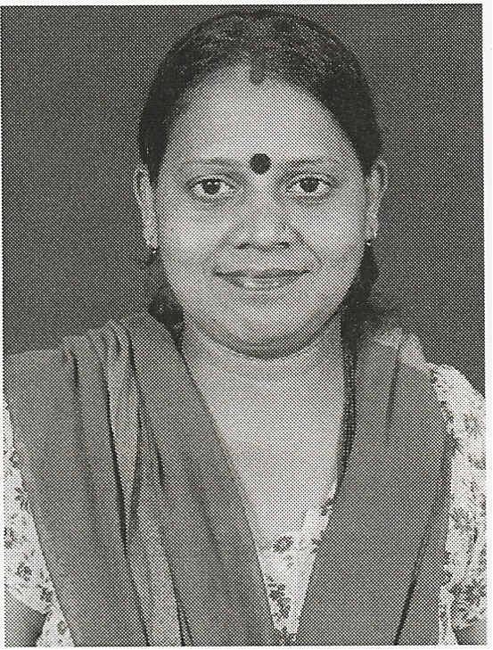Pushpika Freitas
Marketplace: Handwork of India

Prabhavati Suresh Solanki or Prabha says, "When I got married my husband had a permanent job. We didn't have any problems. But his company closed down and we were in a desperate situation. I had two very small children and could not go out to work. I learned of WARE (Women's Artisans Rehabilitation Enterprise) and I realized that I was not the only one who had problems in life. I received immense emotional support from the group. Through the training programs I have received the intellectual stimulation and growth that I needed. I have learned many things, the most important of which has been to dream and to realize my dreams. I want to start my own group, to reach out to more women, to provide them with dignified work and a place where they can come and share their problems, gain strength and mostly to give them an opportunity to make their dreams come true."

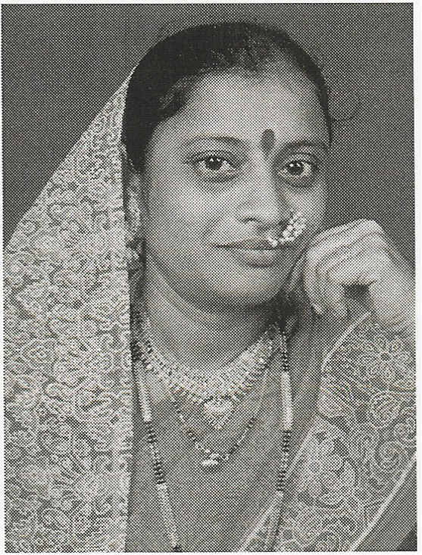

"I got married to a widower with 2 children. Right from the start I knew that I had to work to support the children and my future family. Besides being part of the Arpan Cooperative I have also started a business of cooking food for an office cafeteria. One thing I realized is that there is nothing impossible on this earth. If a woman decides to do something then she can achieve it. She just has to believe in herself. I now want to give this confidence to other women because without the initial step of economic independence women will not know how far they can go."

